Name: M. Manoj Kumar

Register Number:192425114

Course Code: ITA0510

Course Name: Computer Vision

Slot :Slot A
- Perform basic Image Handling and processing operations on the image is to read an image in python and Convert an Image to Gray-scale.

AIM:
To read an image and convert it to grayscale using OpenCV in Python.

PROCEDURE:
  - Install OpenCV (if not already installed):install opencv-python
  - Import required libraries
  - Read the image
  - Convert the image to grayscale
  - Display the images
  - Wait for a key press & close windows

PROGRAM:

import cv2
image = cv2.imread("sample.jpg") # Replace 'sample.jpg' with your image path gray_image = cv2.cvtColor(image, cv2.COLOR_BGR2GRAY) cv2.imshow("Original Image", image)
cv2.imshow("Grayscale Image", gray_image) cv2.waitKey(0)
cv2.destroyAllWindows()

INPUT:
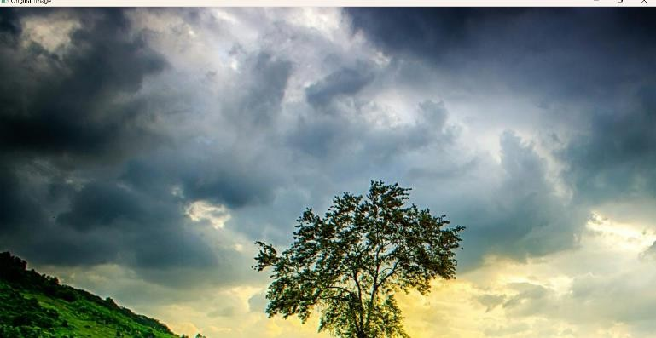

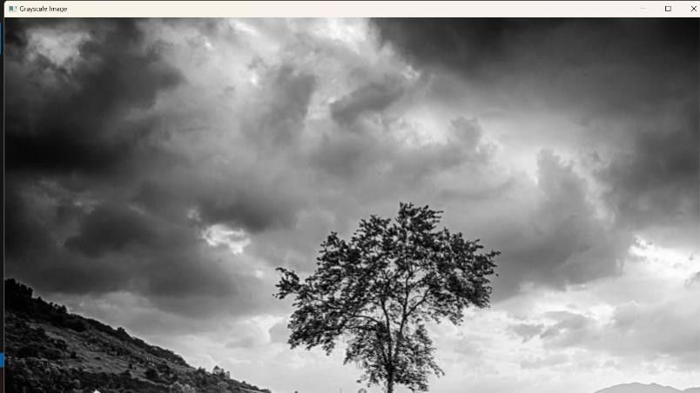
OUTPUT:

RESULT :

Successfully read the input image and converted it to grayscale using OpenCV in Python.

- Perform basic Image Handling and processing operations on the image is to read an image in python and Convert an Image to Blur using Gaussian Blur

AIM:
To read an image and apply Gaussian Blur using OpenCV in Python.

PROCEDURE:
  - Install OpenCV (if not already installed):pip install opencv-python
  - Import required libraries:Use cv2 for image processing.
  - Read the image:Use cv2.imread() to load the image.
  - Apply Gaussian Blur:Use cv2.GaussianBlur() with a specified kernel size.
  - Display the images:Use cv2.imshow() to show both original and blurred images.
  - Wait for a key press & close windows:
    - Use cv2.waitKey(0) to keep the image open until a key is pressed.
    - Use cv2.destroyAllWindows() to close all image windows.

PROGRAM:
import cv2
image = cv2.imread("sample.jpg") # Replace with your image file
blurred_image = cv2.GaussianBlur(image, (15, 15), 0) # (15, 15) is the kernel size cv2.imshow("Original Image", image)
cv2.imshow("Blurred Image", blurred_image) cv2.waitKey(0)
cv2.destroyAllWindows()

INPUT:
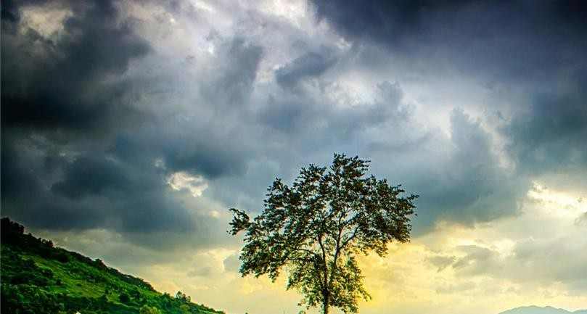

OUTPUT: Blurred image


RESULT :

Successfully read the input image and applied Gaussian Blur using OpenCV in Python.

- Perform basic Image Handling and processing operations on the image is to read an image in python and Convert an Image to show outline using Canny function.

AIM:
To read an image and apply edge detection using the Canny function in OpenCV with Python.

PROCEDURE:
  - Install OpenCV (if not already installed):pip install opencv-python
  - Import required libraries:Use cv2 for image processing.
  - Read the image:Use cv2.imread() to load the image.
  - Convert the image to grayscale:Use cv2.cvtColor() with the cv2.COLOR_BGR2GRAY parameter.
  - Apply Canny edge detection:Use cv2.Canny() with appropriate threshold values.
  - Display the images:Use cv2.imshow() to show both original and edge-detected images.
  - Wait for a key press & close windows:
- Use cv2.waitKey(0) to keep the image open until a key is pressed.
- Use cv2.destroyAllWindows() to close all image windows.

PROGRAM:
import cv2
image = cv2.imread("sample.jpg") # Replace with your image file gray_image = cv2.cvtColor(image, cv2.COLOR_BGR2GRAY)
edges = cv2.Canny(gray_image, 100, 200) # 100 and 200 are threshold values cv2.imshow("Original Image", image)
cv2.imshow("Edge Detected Image", edges) cv2.waitKey(0)
cv2.destroyAllWindows()

INPUT:
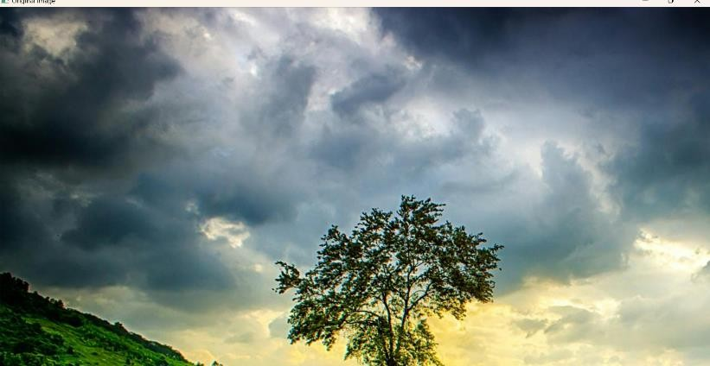

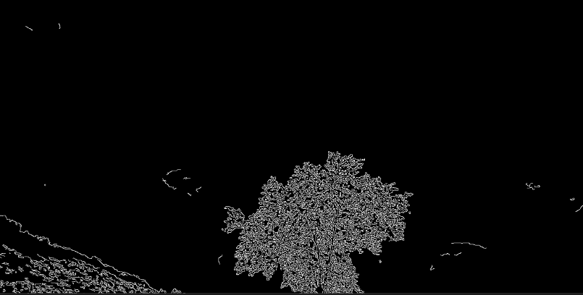
OUTPUT:
RESULT :

Successfully read the input image and applied edge detection using the Canny function in OpenCV.
- Implement histogram equalization on the given image and compare it with the original image using Open CV.

AIM:
To perform Histogram Equalization on an image using OpenCV in Python and compare it with the original image.

PROCEDURE:

  - Install OpenCV (if not installed):
a. pip install opencv-python
  - Import required libraries:Use cv2 for image processing.
  - Read the image:Use cv2.imread() to load the image.
  - Convert the image to grayscale:Use cv2.cvtColor() with cv2.COLOR_BGR2GRAY.
  - Apply Histogram Equalization:Use cv2.equalizeHist().
  - Display the original and equalized images:Use cv2.imshow().
  - Wait for a key press & close windows:Use cv2.waitKey(0) and cv2.destroyAllWindows().

PROGRAM:

import cv2
import numpy as np
image = cv2.imread("sample.jpg") # Replace with your image file gray_image = cv2.cvtColor(image, cv2.COLOR_BGR2GRAY) equalized_image = cv2.equalizeHist(gray_image) cv2.imshow("Original Grayscale Image", gray_image) cv2.imshow("Histogram Equalized Image", equalized_image) cv2.waitKey(0)
cv2.destroyAllWindows()

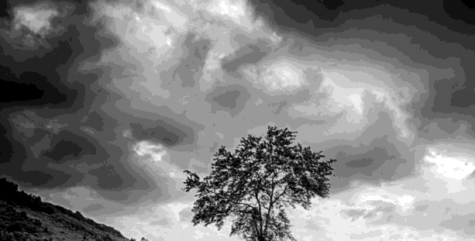
INPUT:

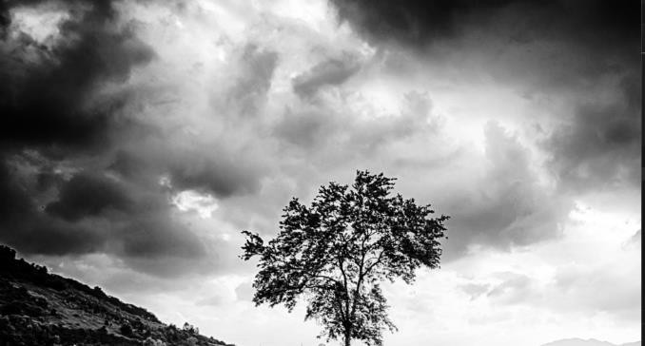
OUTPUT:

RESULT:
Successfully performed Histogram Equalization on the input image and compared it with the original

grayscale image.

